User Manual – New WMS

logo

‘

|  |  |  |  |  |
| --- | --- | --- | --- | --- |
| **Version No.** | **Release Date** | **Prepared by** | **Reviewed by** | **Approved by** |
| 1.0 |  | Priya Dharshni |  |  |

Contents

User Manual – New WMS 1

1 Overview 3

1.1 Accessing the Application - iTracks 3

1.2 Login page 3

2 Customer onboarding setup and Master configuration 5

2.1 Customer Setup 6

2.1.1 Customer Mapping 6

2.1.2 Work order configuration 7

2.1.3 Workflow Configuration 8

2.2 Workflow stage and activity mapping 9

2.3 Job Norms Mapping 11

3 Work order creation 14

3.1 Work Orders list 14

3.2 Manual work order creation- WMS Customers 15

3.2.1 For Books 15

➢ Contact Info 16

➢ Job Info 17

➢ Print Info 17

2.2.2 For Journals 18

➢ Contact Info 18

➢ Job Info 19

➢ Print Info 20

3.3 Manual Work order creation- Non WMS Customers 21

3.4 Auto Work order creation- WMS customers 24

# Overview

## Accessing the Application - iTracks

The iWMS application can be best accessed by either of the below mentioned options,

1. Via CHROME/EDGE browser in WINDOWS and SAFARI/CHROME in MAC by launching the link  <https://iwms.integra.co.in/>
2. By launching the New WMS Thin Client application from the iTools menu. Navigate to iTools -> Software -> General -> New WMS

## Login page

1. Enter the employee ID (ISNO) in the username field and password in the password field. Password is user’s System password
2. Click on the LOGIN button after entering the right credentials to access the iWMS application.
3. If the user is mapped to different DUs he will be able to choose the DU to work on.
4. Once the user log into the application, based on the role and skill mapped the entire menu will differ

**Prerequisites**

1. Make sure the User’s system is connected to the internet.
2. In case the user is working remotely, make sure the system is connected to VPN
3. User should be mapped to a DU and be mapped to the respective Role and Skill
4. The New WMS Thin Client application must be installed for the user machine.

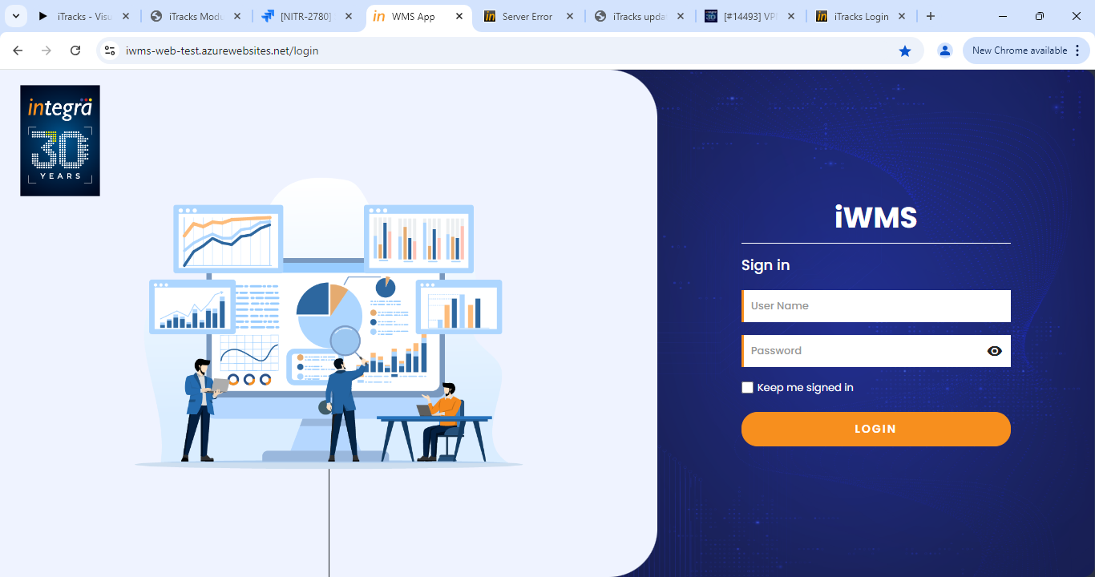

# Customer onboarding setup and Master configuration

The customer onboarding setup described here is applicable only for Non WMS customers. The new WMS customer onboarding is done by the developers which includes all masters configuration, KAM contacts mapping and workflow mapping to customers.

## Customer Setup

The Customer setup menu will be available in the Master menu. The customer setup landing page will list all the previously configured customer setups.

Click on the Add new button to add new customer configuration.

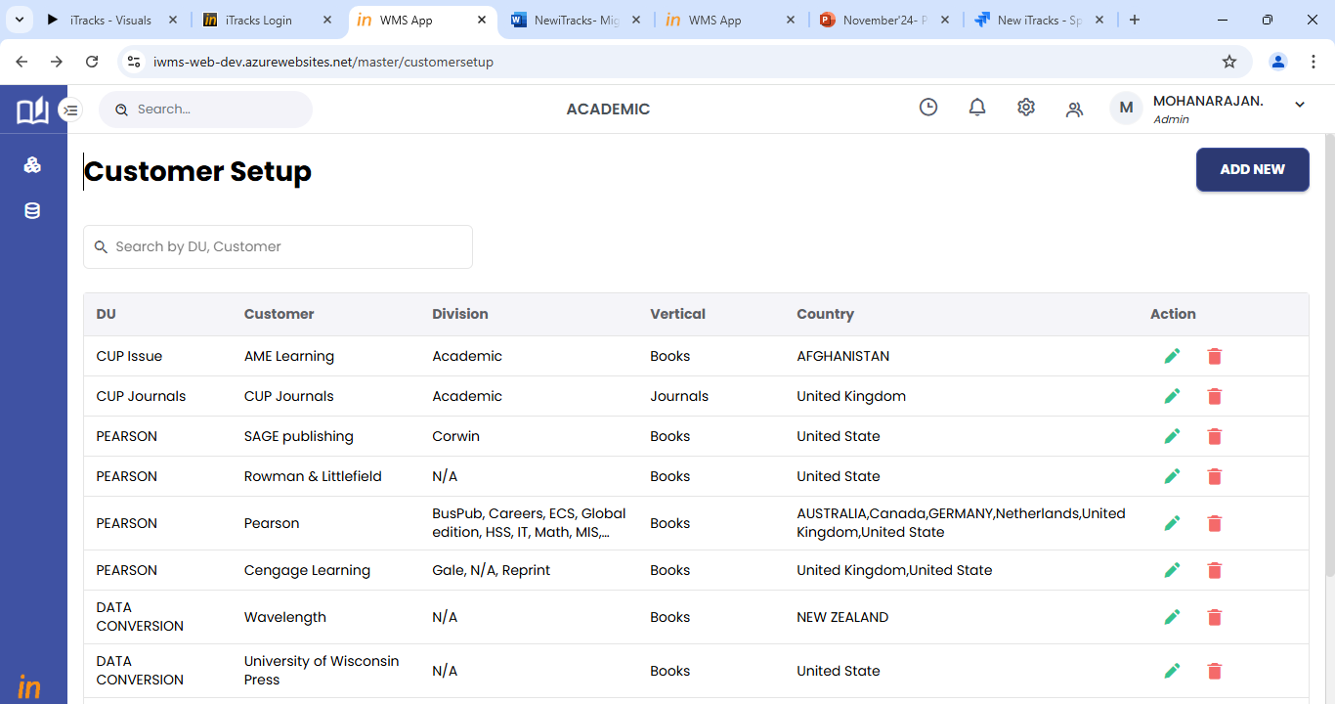

### Customer Mapping

1. Step 1 will be customer mapping.
2. Map the customer to DU, Division, Vertical and country. Division and country can be multiselected.
3. Select the type of customer for the mapped combination.
4. Select the required sections to be displayed for the mapped customer combination.
5. Click on save and next to move to the next step.

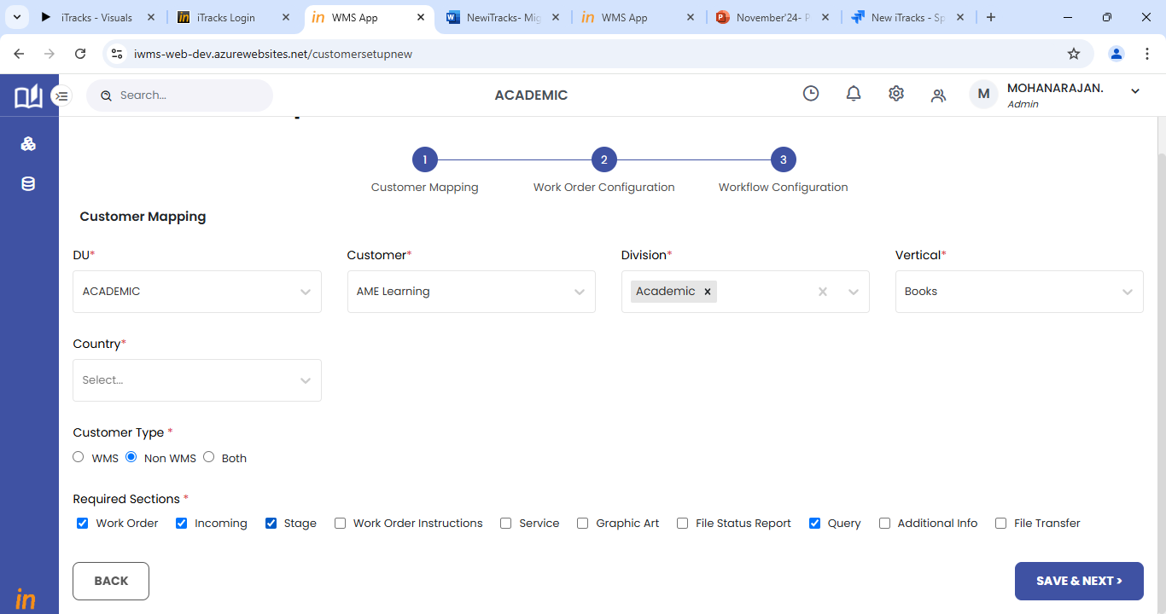

### Work order configuration

1. Step 2 will be work order configuration
2. This page will allow users to select the sections and fields that will be required to create a new work order.
3. A new work order can be created based on the configuration setup done in this step.
4. Use the settings icon on right to select the sections applicable for the customer mapping combination.
5. For each section, the user has to select the fields that are required.
6. The list of all the fields available will be displayed in the left pane of the page.
7. Users can select the required fields from the list.
8. Users will be able to choose the mandatory fields as well.
9. Click on save and next to move to the next section or page.

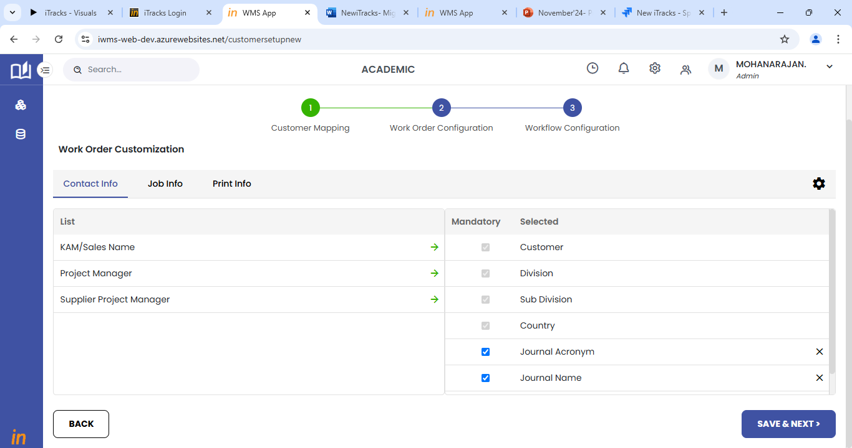

### Workflow Configuration

1. Step 3 will be workflow configuration.
2. Users can select the required workflow from the list of workflows available.
3. If the user wants to add a new workflow, it must be done in workflow list master as explained in section 2.2.

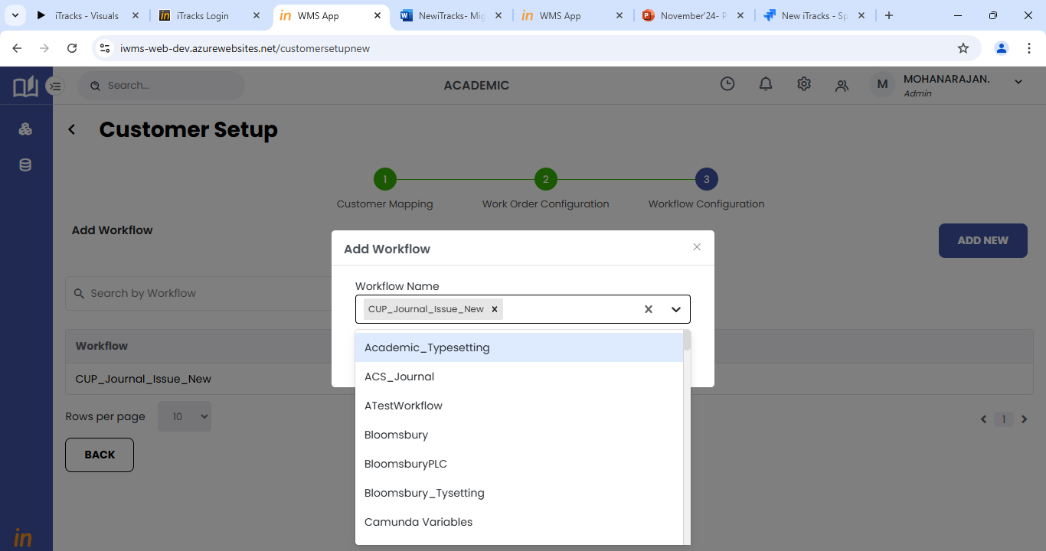

## Workflow stage and activity mapping

The workflow list master is a master for all the workflows in the system.

Workflow master can be accessed from the Main Master menu available in the side menu of the application.

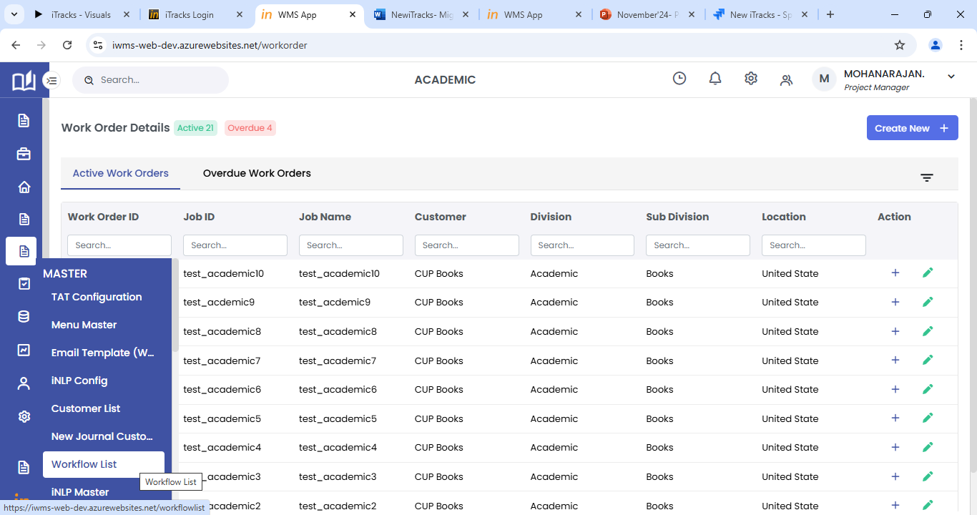

1. The workflow list will display all the workflows available in the system.
2. Click on the settings icon against each row to configure the workflow.

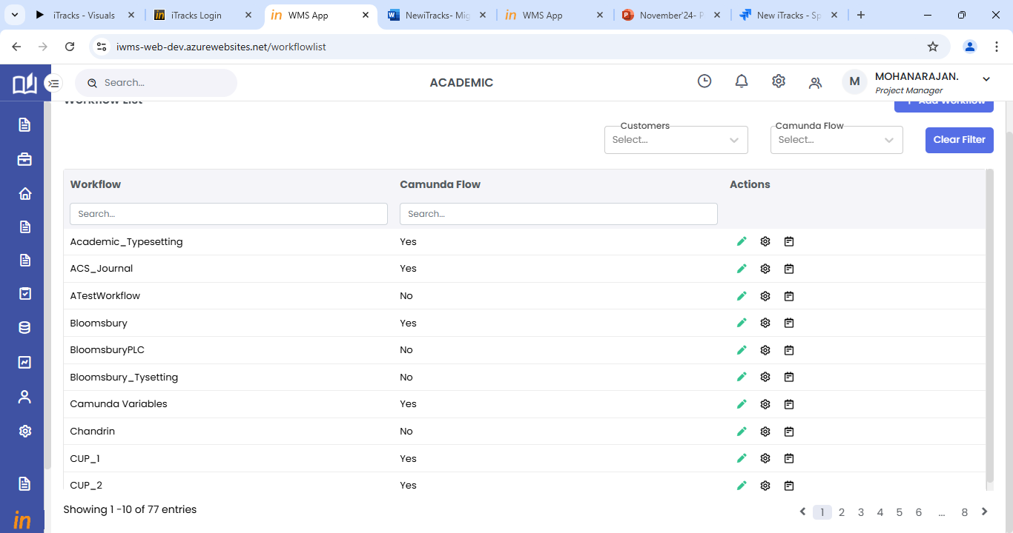

1. For workflow configuration, the user must complete the Stage order and activity order sections.
2. The stage order will list all the available stages in the left pane of the page.
3. The user can select and move the required stages to the right side.
4. After adding the stages, click on save to save the stages list and move on to the next step activity order.

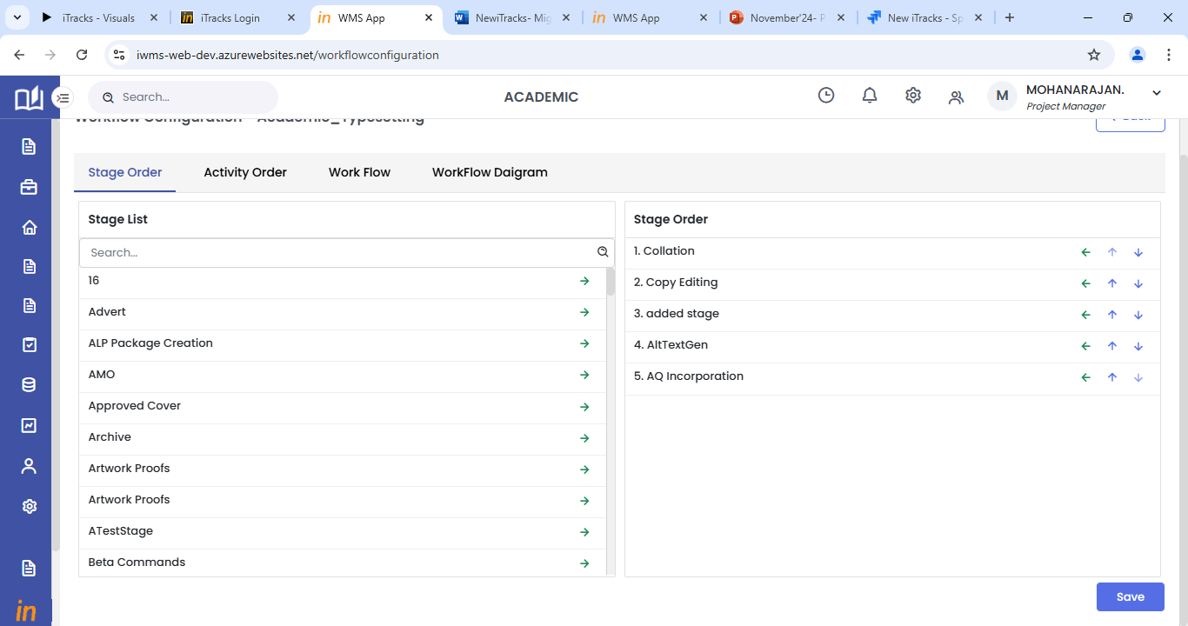

1. The activity order will list all the available activities in the left pane of the page.
2. The user can select and move the required activities to the right side.
3. Select the stage from the drop down provided and then select activities for each stage.
4. After adding the activities, click on save to save the stages and activities configuration.
5. Once added here, the workflow will be able to be selected in the customer setup screen.

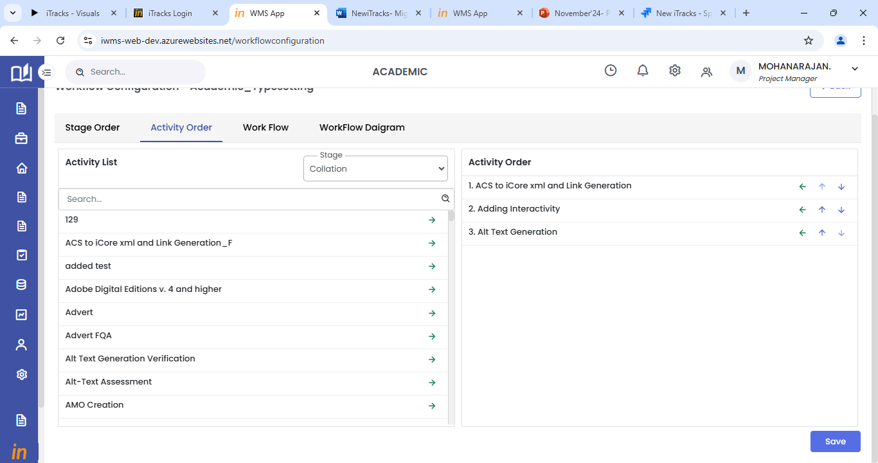

## Job Norms Mapping

1. Norms can be mapped by the Estimations lead user role.
2. Login to the system with the right credentials provided.
3. From the side menu, select Production menu.
4. In the Production menu, click on Job Norms to access the job norms mapping page.
5. In the Job norms mapping page, the first step will be to choose the DU for which norms have to be mapped.
6. Then select the customer using the + icon provided. Multiple customers can be added.

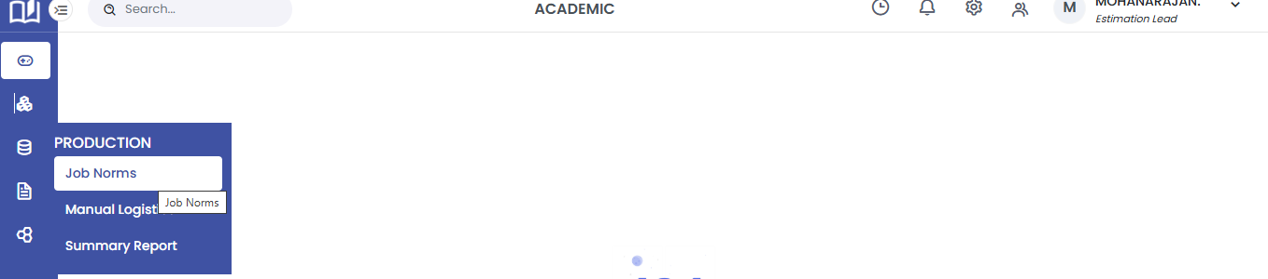

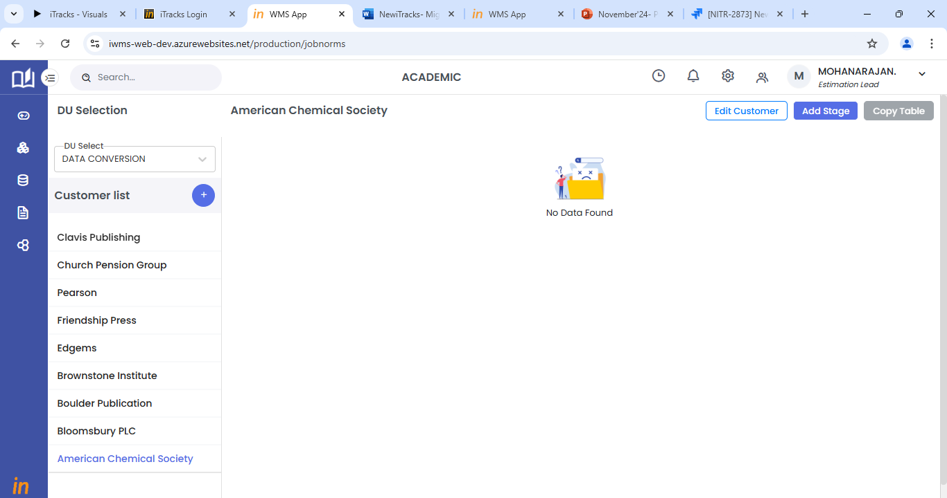

1. Click on the Add Stage button to add the workflow and stage for which norms have to be mapped.
2. Select all the required fields and click on save to add the stage.

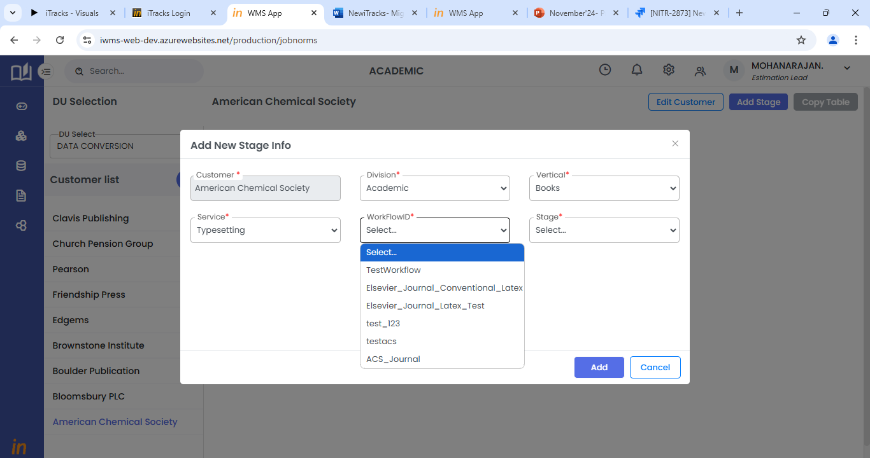

1. Once stage is added, click on the view icon to add activities and norms details.
2. In the view page, click on + icon to add activities for that stage.

Norms can be added for each activity by selecting the required activity once it is added.

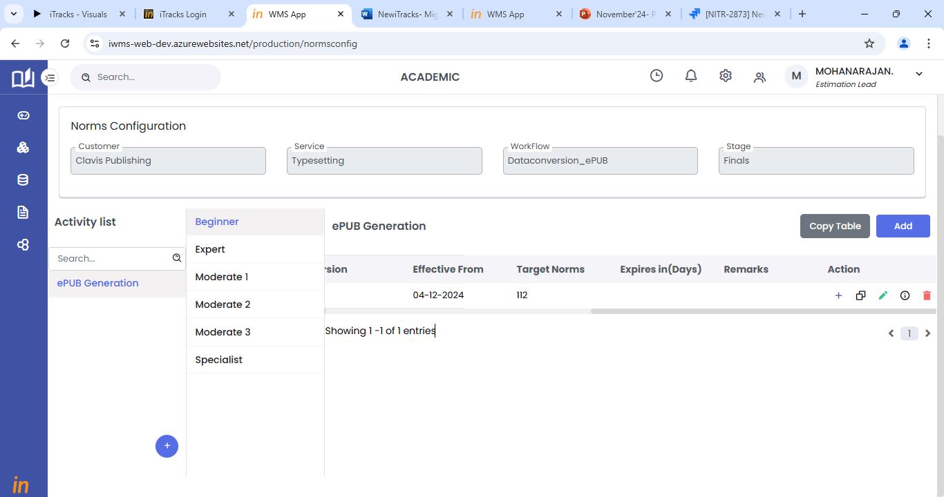

1. Users will be able to select the skill competency for each activity. Norms must be added for all the required skill competencies.
2. Click on pencil icon to edit the norms details
3. Click on copy icon to copy the norms details to another activity or competency.

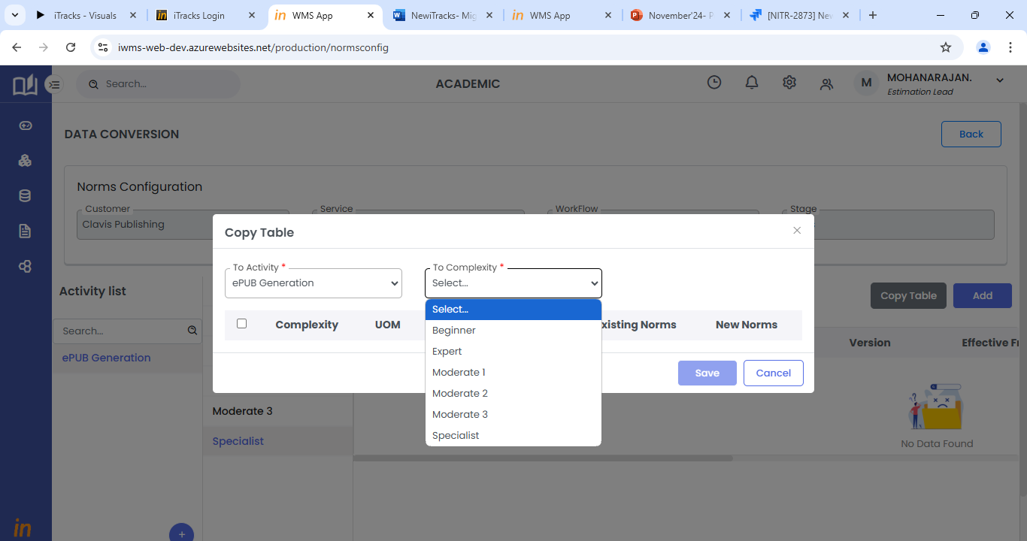

1. Add button will allow the user to add another iteration of the same activity.
2. The copy table button will allow the user to copy the norms details to another activity.

# Work order creation

Work order creation can be manual or automatic as per the customer requirement. All non WMS customers follow manual work order creation. Work order creation can be accessed by PM and PMTL user role only.

## Work Orders list

The Work orders list is the landing page for all users. This is applicable for both WMS and Non WMS customers.

1. Click on the **Work Orders Menu** to view the existing workorders (Active, Complete and Overdue) list or to create a New Work Order
2. Use the scroll bar to move across the list

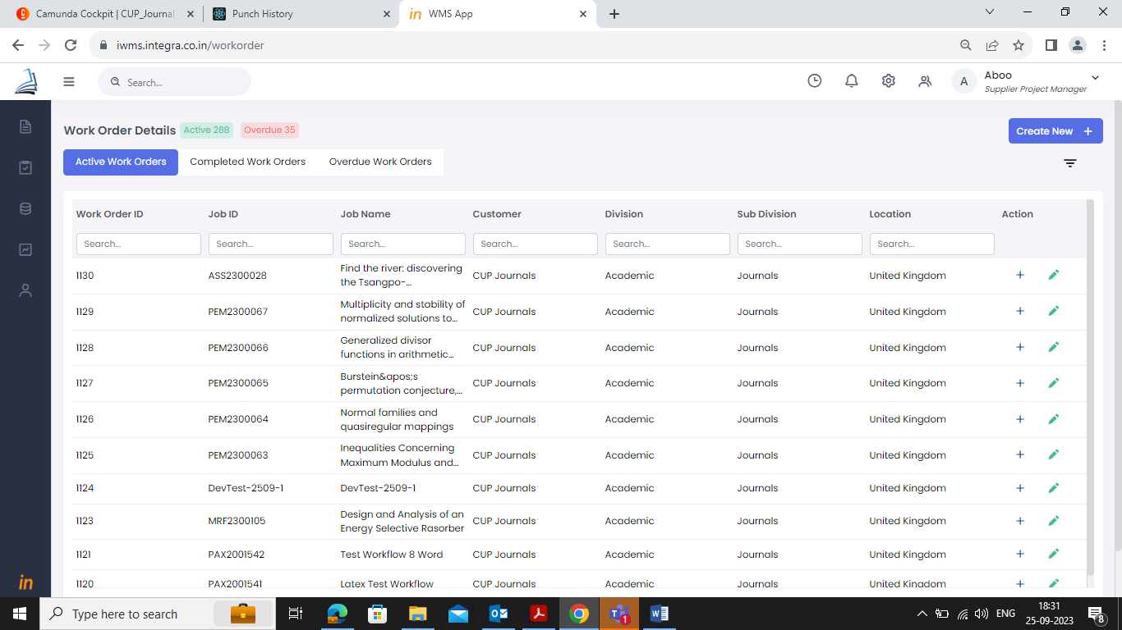

1. To search for a particular work order, use the search filter option provided for each column.

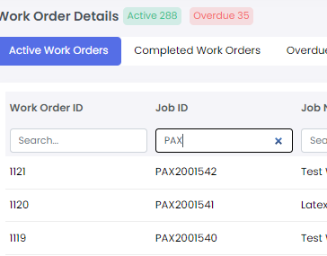

1. Under Action column, Click on the ‘**+**’ button to expand the row which will display the key information tabs (clickable hyperlinks) associated with the workorder.
2. The following menus will be displayed as hyperlinks, Job Info, Service, Stage, File Status Report, Query
3. Click on the required Menu item to go to respective work order tab.
4. Under Action column, click on the **Edit** icon to edit respective work order details.

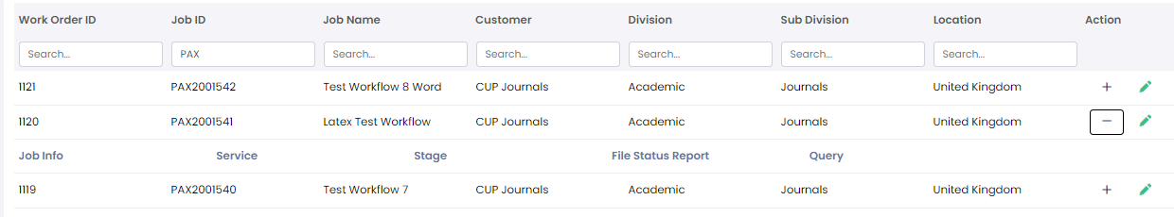

## Manual work order creation- WMS Customers

A work order can be created manually or automatically by the WMS system. If the work order creation is automated, the user will still be able to edit work order details using the edit icon in the work orders list page.

### For Books

1. Use the **Create New +** button to create a new Work Order (for manual process). The create new button will open the workorder screens with 3 sections

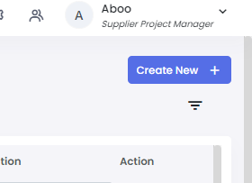

### Contact Info

1. Select relevant data from the drop down provided for various fields.

Select customer, division, sub-division, country from the drop-down fields.

The other fields will get auto-populated based on above mentioned field combination. If there are more than one contact mapped, it will not get auto populated, please select the contact from the drop down provided.

1. If you wish to clear the entered data, click on the **Reset** button.
2. To move to the next section after entering the contact details, click on the **Next** button.

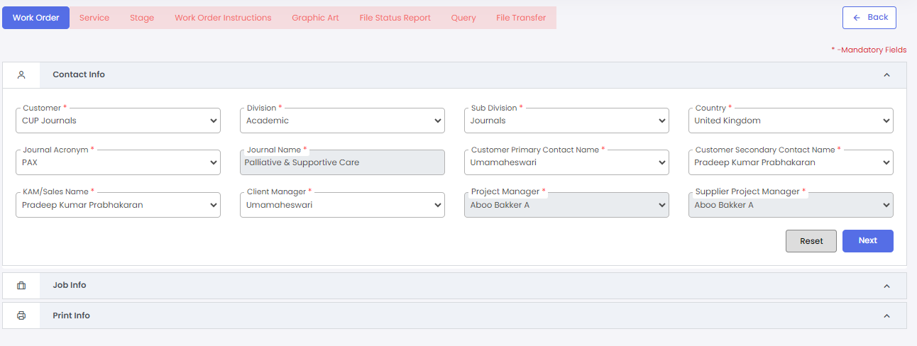

### 

### Job Info

1. Enter Job id and click on the Check Availability option provided below the field to check job id availability. This job id will be the book code for the entire work order. Make sure you enter the right information.
2. Enter job name in the provided field. This is the title of the work order to be created. Make sure you enter the right information.
3. Select the services to be done for this workorder from the drop down provided. If there is only one service mapped to this customer, it will be auto populated or else select required services from the drop-down.
4. Attach order email by clicking the upload icon provided
5. Click on the next to move to next section or previous to move to previous section

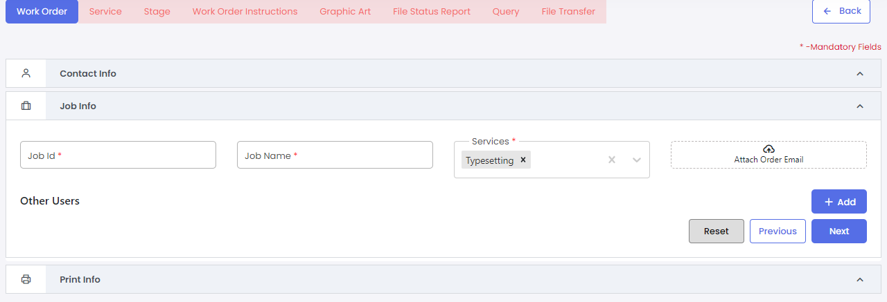

### Print Info

1. Select relevant information provided in the drop down for various fields. This section’s fields are displayed based on customer.
2. Enter the no. of chapters to be worked for this work order.
3. Fill all mandatory fields and click on the save to save all details.
4. Once save is clicked, the workorder will be created.

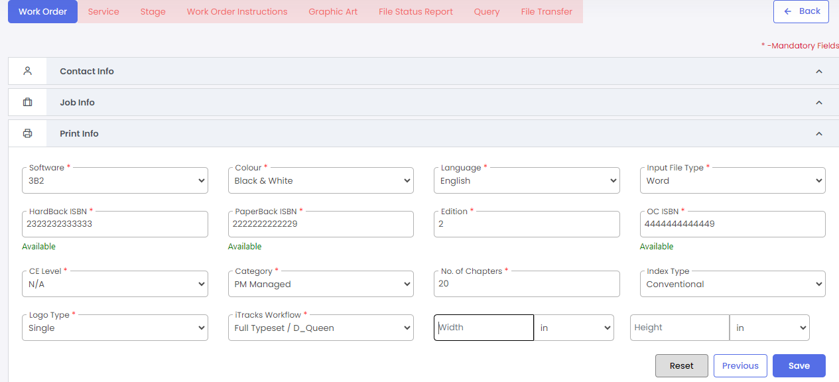

### For Journals

1. Use the **Create New +** button to create a new Work Order. The create new button will open the workorder screens with 3 sections



### Contact Info

1. Select relevant data from the drop down provided for various fields.

Select customer, division, sub-division, country from the drop-down fields.

1. Once the sub-division is selected as journal, the fields related to journal workorder will be displayed.

Select the journal acronym from the drop down provided.

The other fields will get auto-populated based on above mentioned field combination. If there are more than one contact mapped, it will not get auto populated, please select the contact from the drop down provided.

1. If you wish to clear the entered data, click on the **Reset** button.
2. To move to the next section after entering the contact details, click on the **Next** button.

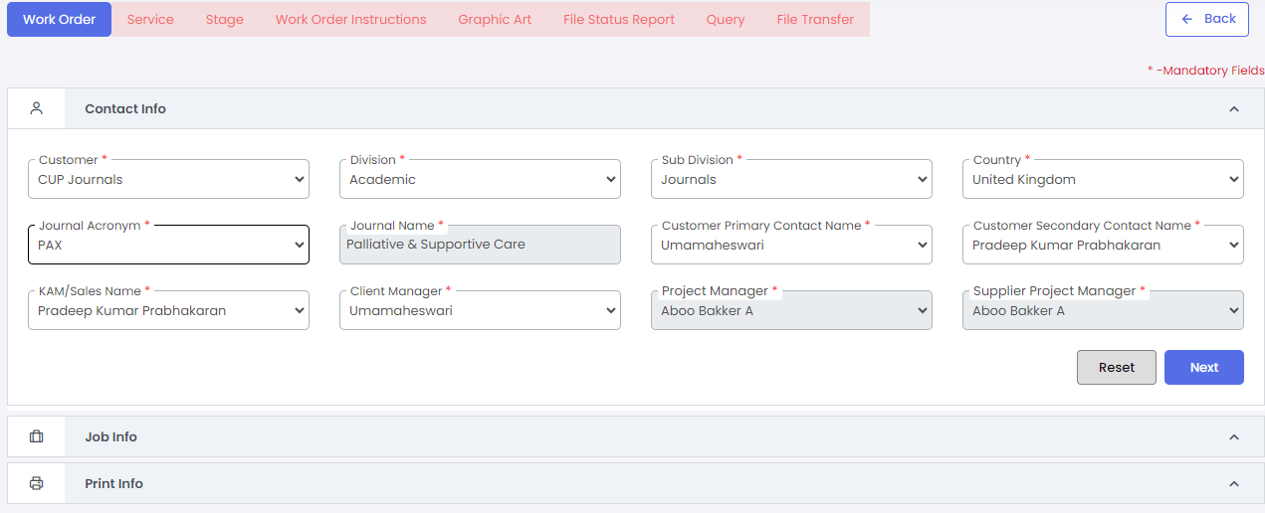

### Job Info

1. Choose the Job type (Article/non-article/issue) from the radio button provided. Other fields in this section will change according to the job type selected.
2. Enter the DOI. Make sure you enter the right information.
3. Enter the Job id. This job id will be the book code for the entire work order. Make sure you enter the right information.
4. Enter the job name in the provided field. This is the title of the work order to be created. Make sure you enter the right information.
5. Select the services to be done for this workorder from the drop down provided. If there is only one service mapped to this customer, it will be auto populated or else select required services from the drop-down.
6. Attach order email by clicking the upload icon provided
7. Other users section will display the contacts mapped to the selected journal. Use the Add button to add more contact details.
8. Click on the next to move to next section or previous to move to previous section
9. For an issue work order, enter the issue number and volume number in the provided fields.

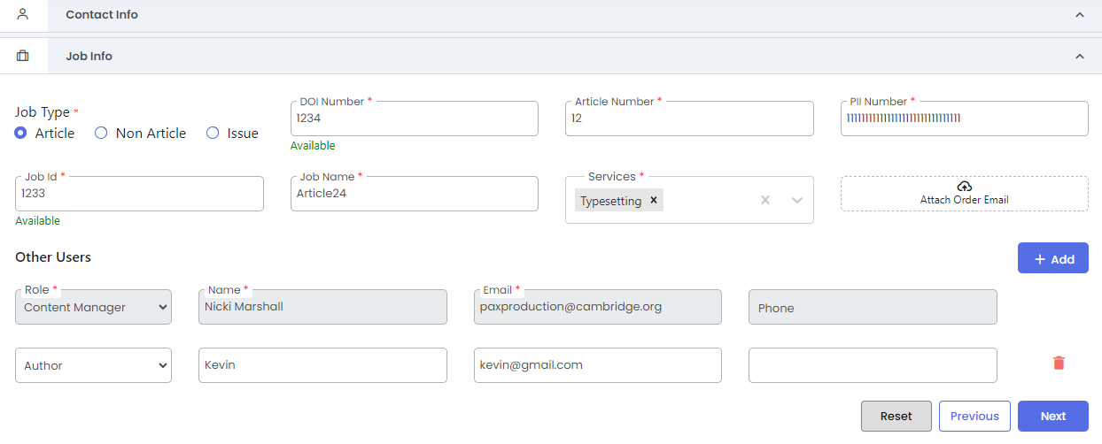

### Print Info

1. The Software, color, language, print ISSN, Online ISSN, Trim size will be auto fetched from the masters based on the journal selected.
2. Choose the input file type and CE Level from the drop down provided.
3. Use previous button to go back to the previous section.
4. Once save is clicked, the workorder will be created.

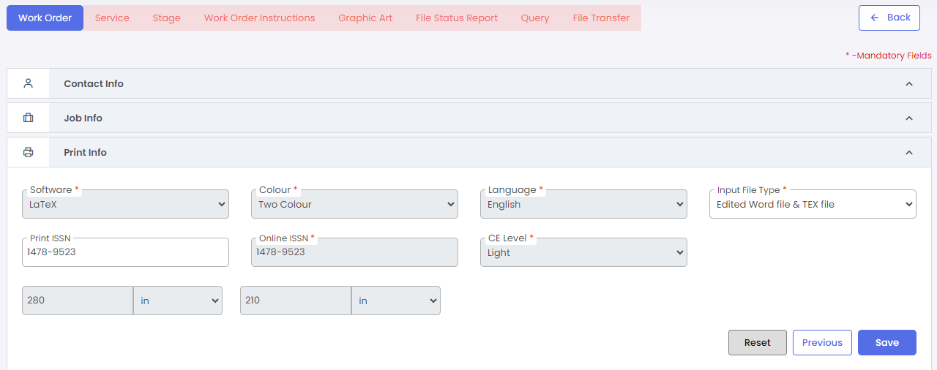

## Manual Work order creation- Non WMS Customers

A work order can be created manually by clicking the create new button from the Work order home page.

1. Use the **Create New +** button to create a new Work Order.
2. Choose for which type of customer the work order has to be created (WMS or Non WMS). The screens change as per this selection.



1. For Non WMS customers, Select the DU, Customer, Division, Vertical, and country for which work order has to be created.
2. DU will be auto populated based on the logged in user’s DU.
3. Select the relevant Customer, Division, Vertical, and country from the dropdown provided.

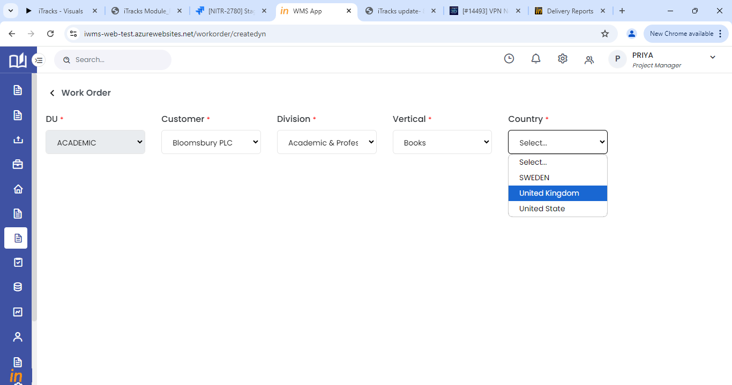

1. Once selected, the page will display the application tabs as per the customer setup made.
2. To create a work order, user has to fill all the mandatory fields in the sections configured as per the customer setup.
3. In all configured sections, select relevant data from the drop down provided for various fields.
4. Some fields will get auto-populated based on customer, division, sub-division, country configuration. If there are more than one contact mapped, it will not get auto populated, please select the contact from the drop down provided.
5. If you wish to clear the entered data, click on the **Reset** button.
6. To move to the next section after entering the contact details, click on the **Next** button.
7. The last section will have the **save** button.

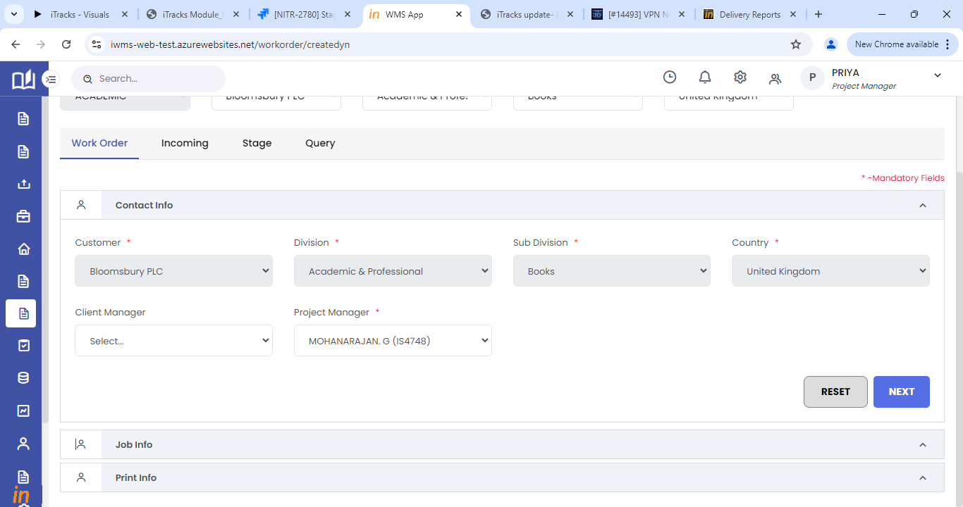

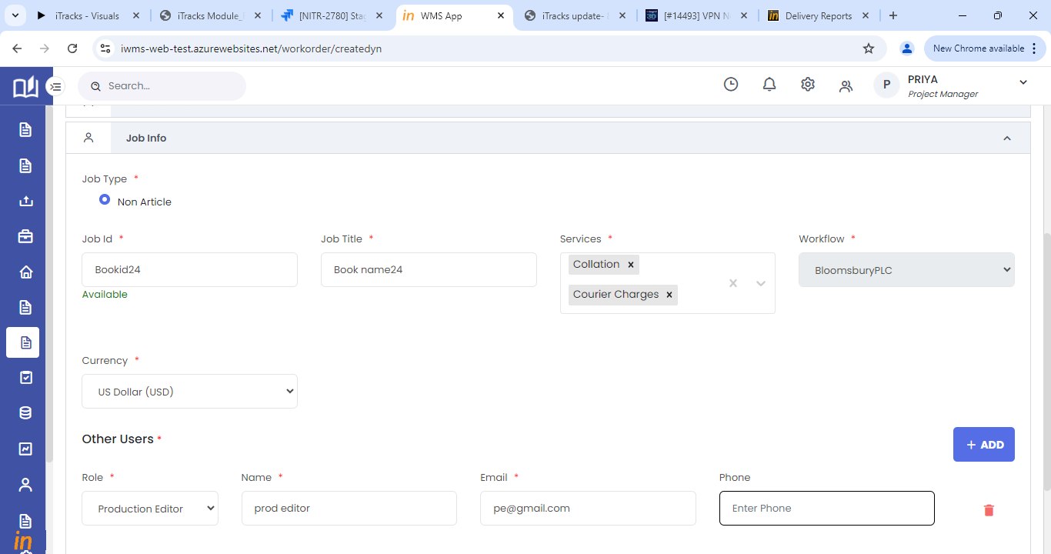

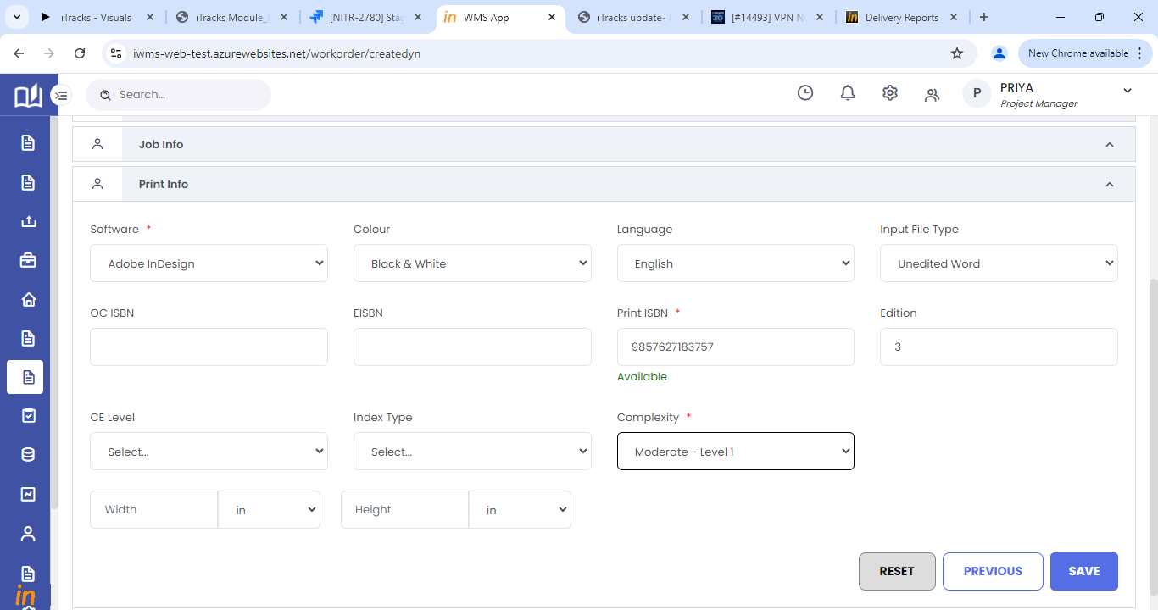

1. On click of save in the last section, the work order will be created.

## Auto Work order creation- WMS customers